How to draw a dog
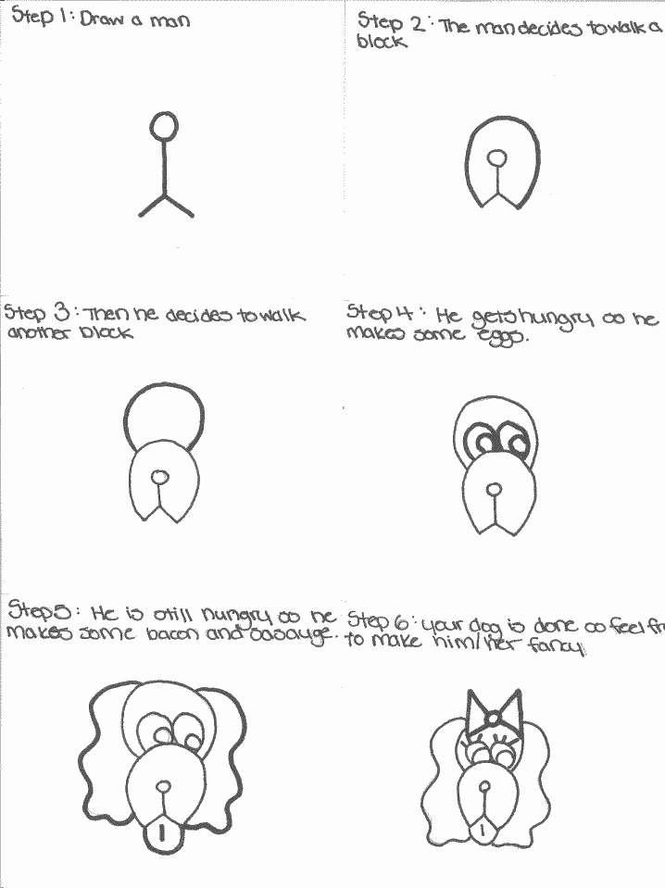

Learn to cross stitch!
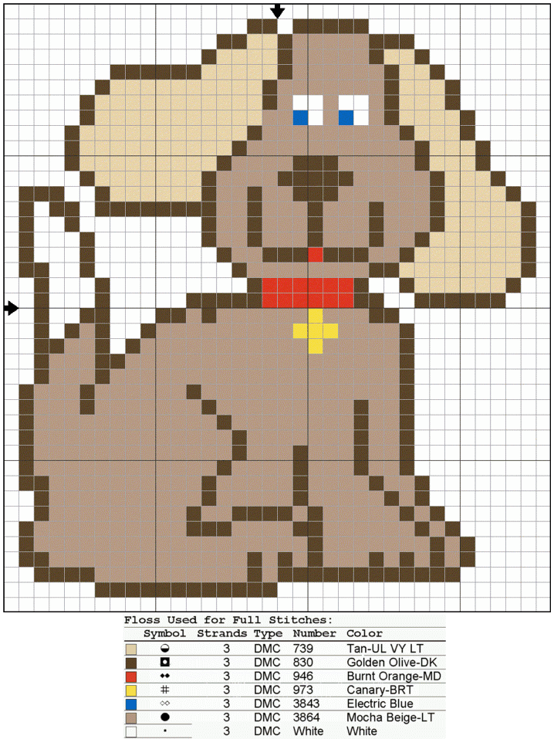

Circle dog craft

Circle Dog Craft -
Shapes, Scissor Skills, Colours, and Counting Practice

Materials:
- scissors,
- glue,
- paper
SCISSOR SKILLS:
- This craft has lots of circles to cut out -- good scissor practice!
FRACTIONS:
- Point out that the ears and mouth are half a circle.
COLOuRS:
- verbally instruct the children on how to assemble the shapes using the colours of the shapes. (ie: Take the black circle and glue it on the grey circle.).
SIZES:
- show the children two circles and ask -- is this one bigger, smaller or the same size as that one.
COUNTING:
- Count the circles.

Assembly Directions:
- 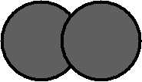Glue the two large grey circles, slightly overlapping, on top of each other (sort of like a figure 8 lying down).
- Glue the last light grey circle under the other two as a muzzle.
- Glue the two large half circles onto the edges of the head as ears.
- 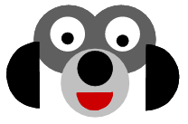Glue the small half circle mouth, the two eyes and the small black circle (nose) onto the head.

Dog Paw Print Birthday Cake
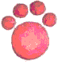  Clifford the Big Red Dog | 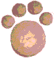  Scooby Doo
You could also do a white one with chocolate toes for a Dalmatian puppy or snoopy theme.

Materials:
- Follow instructions to make a sponge cake
- mix white icing + food colouring
- regular round cake tin
- cupcake tin

Instructions:
This cake is very simple. It's one round cake and 4 cupcakes all frosted with an appropriate colour and arranged like a pawprint.

Learn to sing a song about Bingo the dog

Lyrics to
"B-I-N-G-O"
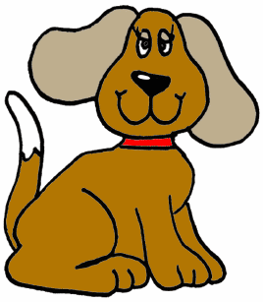
There was a farmer had a dog,
And Bingo was his name-O!
B-I-N-G-O, B-I-N-G-O, B-I-N-G-O
And Bingo was his name-O!

Sing the song the first time through, then on the second time replace the B in BINGO with a clap. The third time, both the B and I are clapped instead of sung; the fourth time B, I and N; the fifth time B, I, N and G and the last time, all the letters BINGO are clapped rather than sung.

