Our topic | Our learning | Aspects of the National Curriculum we will cover | Questions we might answer | Books we may read | Ways we might enrich our learning further
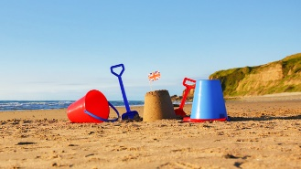  Oh, I do like to be beside the seaside!  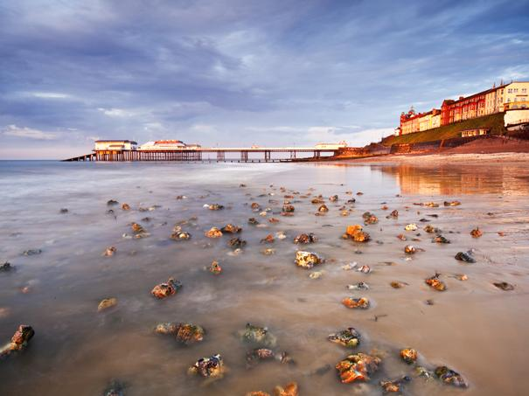 | As scientists we will focus on living things and their habitats. We will investigate where bugs live and why, find out about life cycles and grow edible plants. | We will explore and compare the differences between things that are living, dead, and things that have never been alive, find out about habitats and explore food chains. | What does an eagle eat?  Why does a wood louse live under a log? | 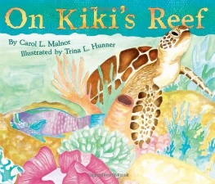  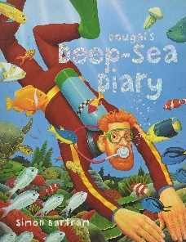  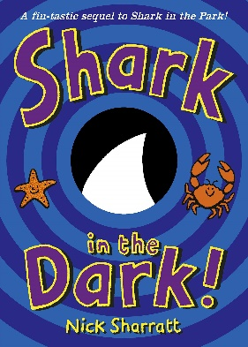  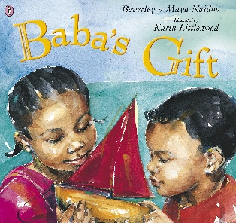 | End of theme visit to the seaside, exploring using our senses and our new historical and geographical knowledge  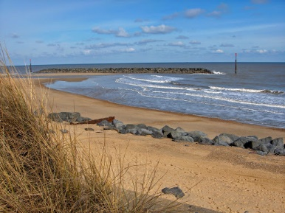  Meeting members of the Jewish faith  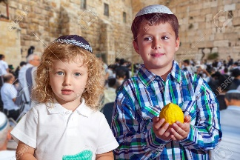
 | As historians we will be finding out about seaside holidays in the past. We shall also discover facts about Queen Victoria, whilst thinking about life 100 years ago and learn about Edith Cavell. | We will find out about significant historical events, people and places in our area | Why did they wear different clothes at the seaside 100 years ago?  What did Edith Cavell do?
 | As geographers we will look closely at the features of our local seaside, including beaches, cliffs and the towns. | We shall use geographical language to describe the physical and human features of our seaside. | Why do people visit the seaside?  Is the seaside the same everywhere?
 | As artists we will observe natural seaside resources to develop our drawing and design skills. We will use pencils, crayons, paint and charcoal. | We shall use a range of materials creatively to design and make products and to use drawing, painting and sculpture to develop and share their ideas, experiences and imagination | How can I draw the shell using pastels?  How did Monet use colours in his seaside paintings?
 | As musicians we shall share songs and music related to the seaside, composing our own rhythms and tunes. | We will be singing, playing untuned percussion instruments and creating our own compositions | How did Benjamin Britten use the seaside to influence his music?
 | In RE we shall find out about Shabbat, the Daily Life of a Jewish child and learn about their place of worship, a synagogue. | We will have a focus on Judaism, finding out about the lives and beliefs of a Jewish family. | What do they do on Shabbat?  Is the synagogue the same as a church?

