THE THINKING COLLECTION

SONG

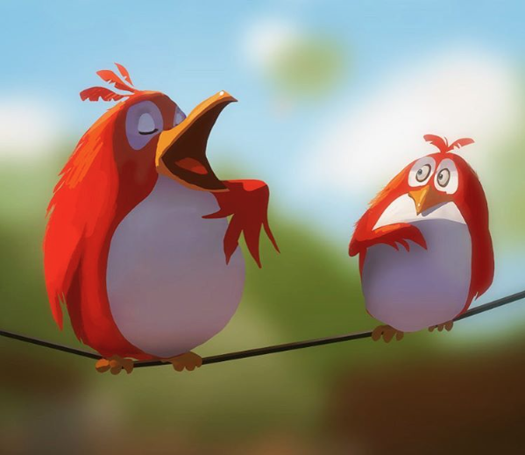

Credit: Goro Fujita

- What is the bird on the left doing? How do you know?
- Do you think that the bird’s song is good or bad? Why?
- Does that bird often sing?
- What is the bird on the right thinking? What might it say when the other bird has finished singing?
- Which bird is more confident?
- Have you ever been in a situation like this one?

I BELIEVE I CAN

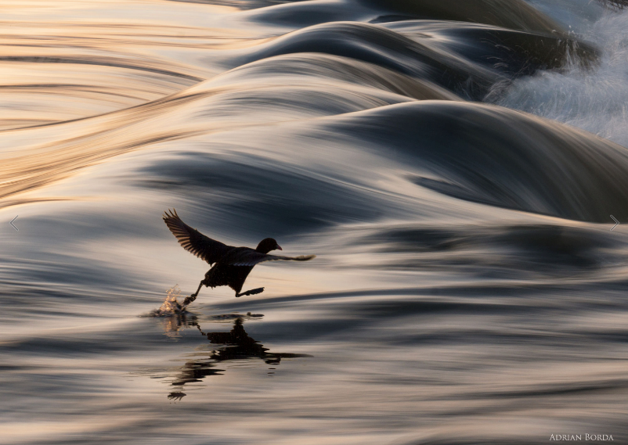

Credit: Adrian Borda
- What is happening here?
- Is the bird walking on the water? How? Why?
- Is this bird special? Can it fly?
- Do you think this is the first time the bird has walked on water?
- The title is ‘I Believe I Can’. If the bird doubted itself, do you think it would still be able to walk across the water?
- How important is self belief?
- Have you ever ‘failed’ because you lacked confidence?
- Have you ever succeeded because you believed you could?
- What does failure feel like? What about success?
- Has anyone ever achieved something other people thought to be impossible? What qualities did they have?

PATIENCE

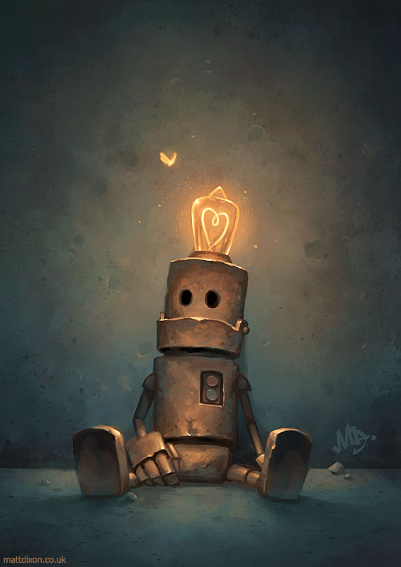

Credit: Matt Dixon

- What is the robot doing?
- Is it looking at the moth?
- Why is the light bulb on his head lit up? Has he had an idea?
- Is the shape of the wire inside the lightbulb important?
- Does this robot have any friends or family?
- Can he feel emotions? If so, how do you know? Which ones?
- How do you feel towards the robot? Why?
- Why is this image called ‘Patience’?
- Talk/write about a time when you had to be patient. How did it feel? Was it worth it? Is being patient a good thing?

QUIET TIME

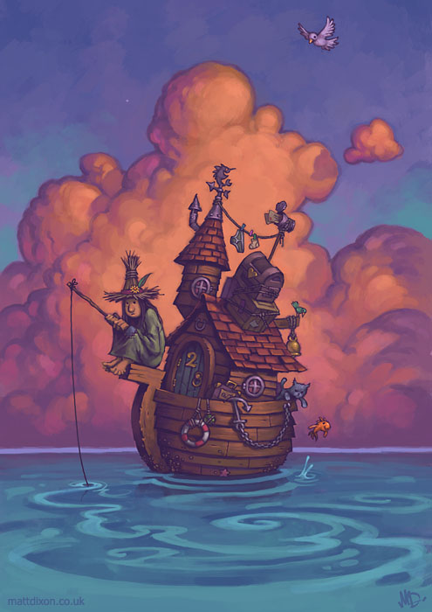

Credit: Matt Dixon

- Who is the woman?
- Why does she live on a boat?
- Does she have everything she needs?
- Is she happy?
- Is she lonely?
- Is being alone the same as being lonely?

TREES

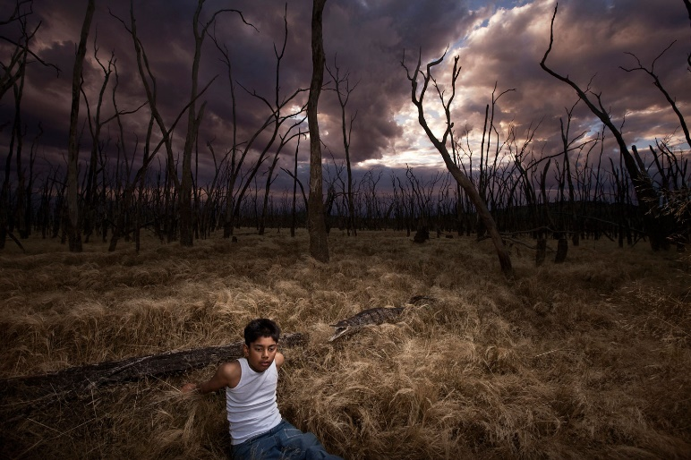

Credit: Jeremy Blincoe

- How does this photograph make you feel? Why?
- Who is the boy? Why is he there? How is he feeling?
- Why aren’t there any leaves on the trees?
- Look at the sky. What is the effect of the colours?
- Is there a message behind this picture?

WRITING ON RAW MATERIAL

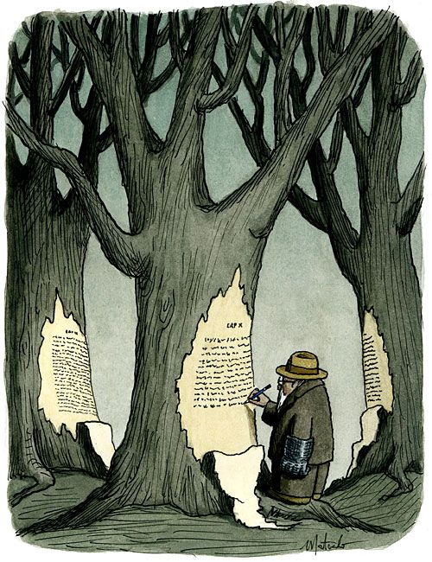

Credit: Franco Matticchio

- What is the man writing?
- Why is he writing on a tree?
- What does he have on his hand?
- Who do you think wrote on the other trees?
- How are trees and writing linked?
- What is the message behind this picture?

