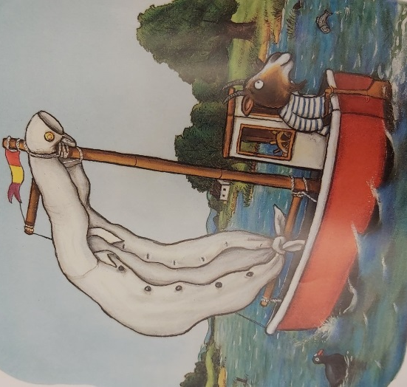
Dear George,
I am writing to thank you for giving me your white shirt.
I am the proud owner of a lovely sailing boat and one day I was out sailing on the calm sea. Suddenly, a fierce storm blew up and it began to rain heavily. The wind blew strongly and whipped up giant waves. My little boat was rocking in the rough sea and then unfortunately a huge gust of wind blew away my sail. I was very upset because I didn’t know what to do. I don’t have enough money to get it repaired. How I wished I had a strong new sail for my boat!
However, then you came along, George. When you gave me your new white shirt I was over the moon! It was so kind of you! My boat now has a magnificent sail and I am very grateful to you.
love from
Goat xx

