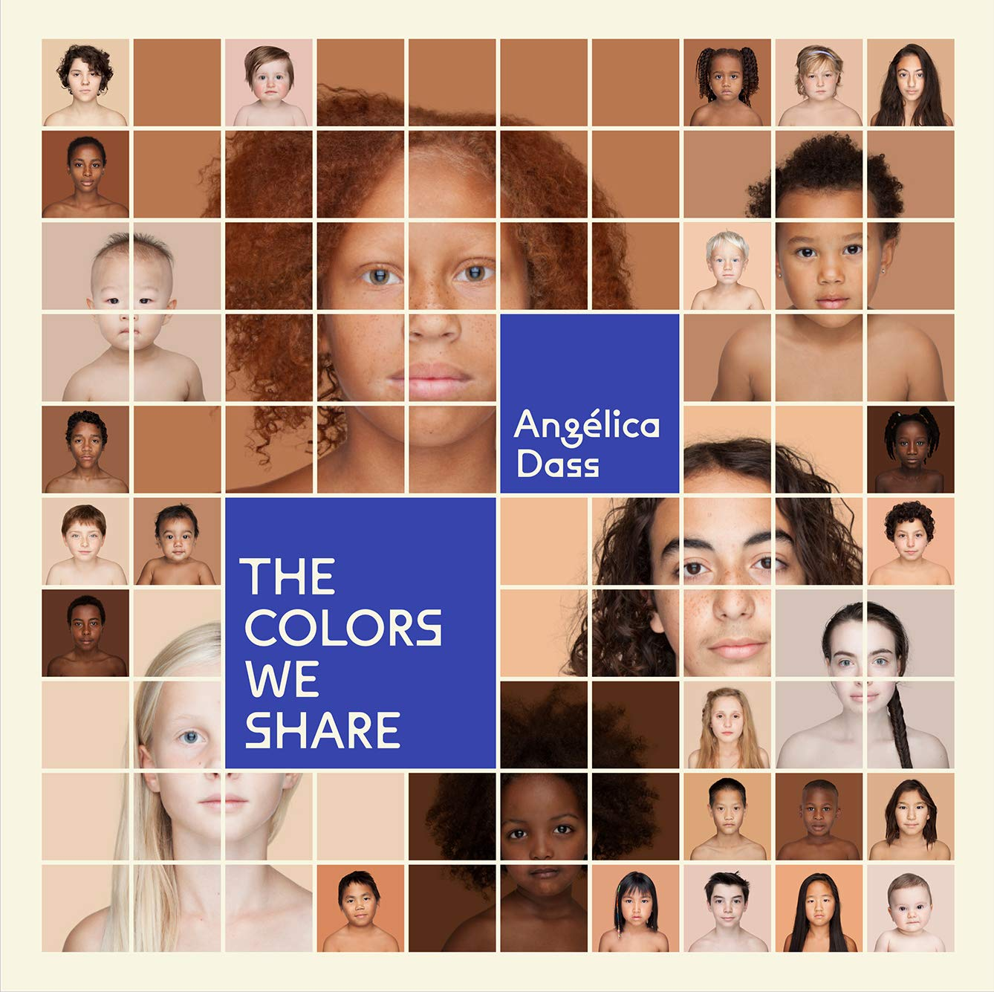
Week beginning 15th November 2021
This is a very exciting and different week. The whole school will look at the book – The colours we share. From this we will all create self-portraits by examining our features very carefully. We are going to mix colours and test them on our hands until we create an exact match. When the base coat is dry we will then mix further colours for our eyes, lips and other special features such as freckles. We have another book for Red Skippers which looks at skin colour in relation to food. We will have fun thinking about which food may match our hands, leg or hair! I hope we will be able to have an art show soon so you will be able to view our portraits
The Reception sounds will be y, x, ch and sh and the split diagraph (magic ‘e’) for Years One and Two. Our words are not, got, in and time.
In maths our focus for Reception will continue to be on reading and writing numbers to 20 and matching numbers to amounts. Year One and Two will work on doubling and halving, (to 5+5 and 20+20). Year One will also work on the days of the week and months of the year whilst Year Two learn to partition to add and subtract 11. Eg: 22 + 11 = 22 + 10 = 32 + 1 = 33

