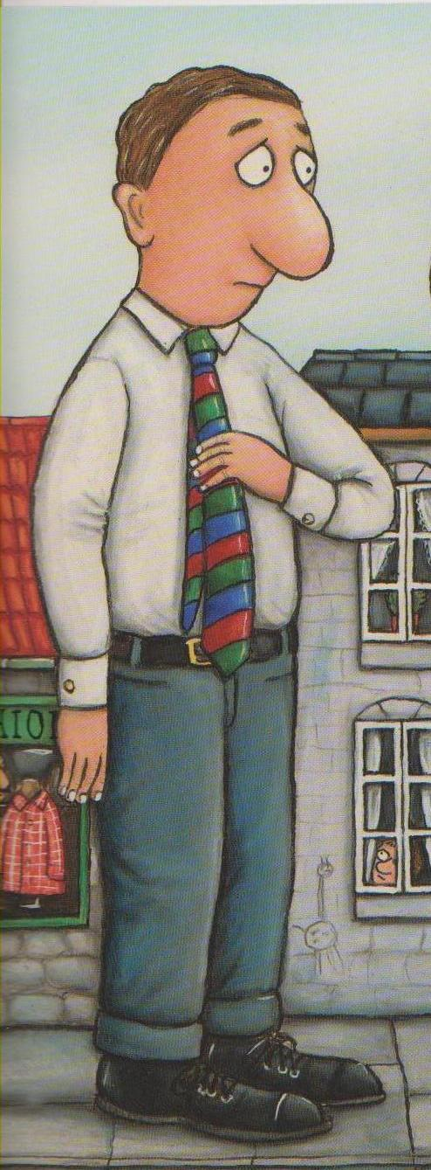
The smartest giant in town

Write sentences using “this is a” or “these are”.

















