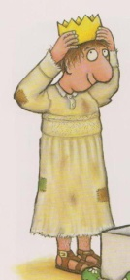
The smartest giant in town
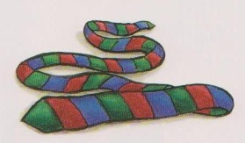
Your ______ is a scarf for a cold giraffe,

Your 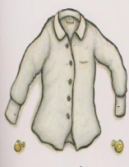 _________ is on a boat as a sail for a goat,
Your 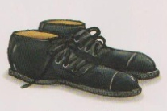 _________ is a house for a little white mouse,
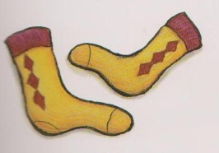
One of your _________ is a bed for a fox,

Your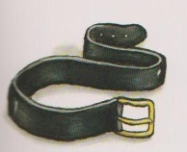 _______ helped a dog who was crossing a bog,
So here is a very fine crown, to go with the 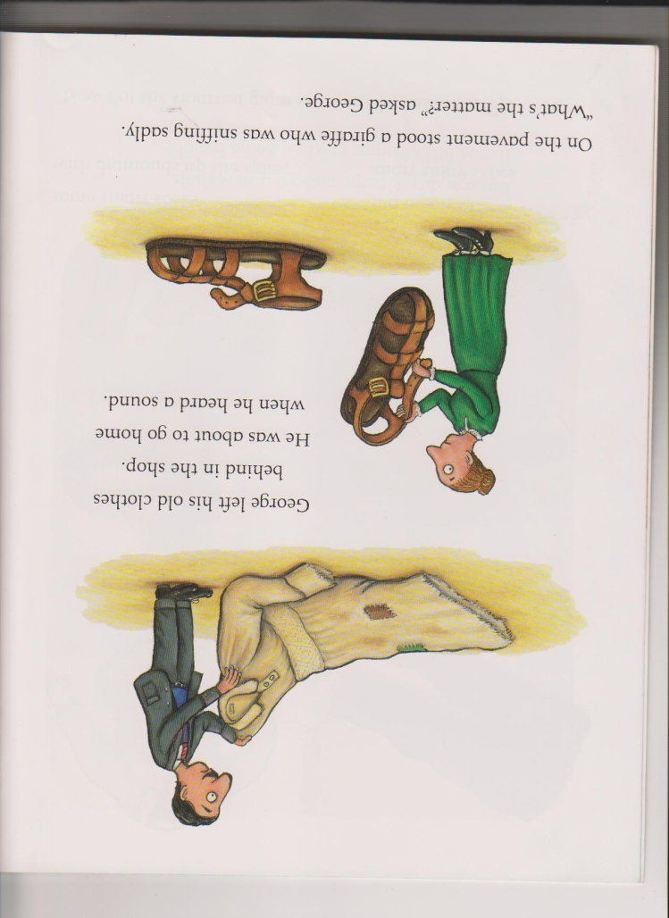 ______ and 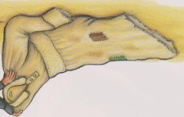 _______ of the kindest giant in town.

